**Philip Park**

**Kuchisake-onna**

**Concept:**

This finished product for this project will be an enhanced/juicy version of the mod. The main structure of this game will stay the same. It will mostly consist of a text being displayed in the top center of the screen and two choices being available in the bottom. Players will have to make wise decisions in order to ensure that they can survive until the end of the game. The setting of the game takes place in an abandoned building where they have an encounter with Kuchisake-onna.

What will change is that the story will actually branch out into multiple scenarios during the game. In the initial prototype, the story was rather streamlined, and many of the choices that the players made actually did not matter too much in the long run. In the updated build of this game, player choices will lead to drastically different outcomes.

Because there is not much in terms of visuals that needs to be done for this game, the text will need to be very juicy. Many effects will be made in order to make the text as alive as possible. I will likely utilize Textmesh Pro in order to create effects such as shaking text, falling text, spiraling text, etc.

I will also likely create actual buttons for players to press on when making a choice. Additionally, in order to select a choice, players will actually need to move a cursor to on top of a choice and select it in this way. This creates opportunities for there to be multiple choices and for the chance that the format/layout of the screen to be different from that of the original prototype.

A tutorial stage is also very likely to be implemented in the beginning of the game.

Visual References:

Mother 3 Ending

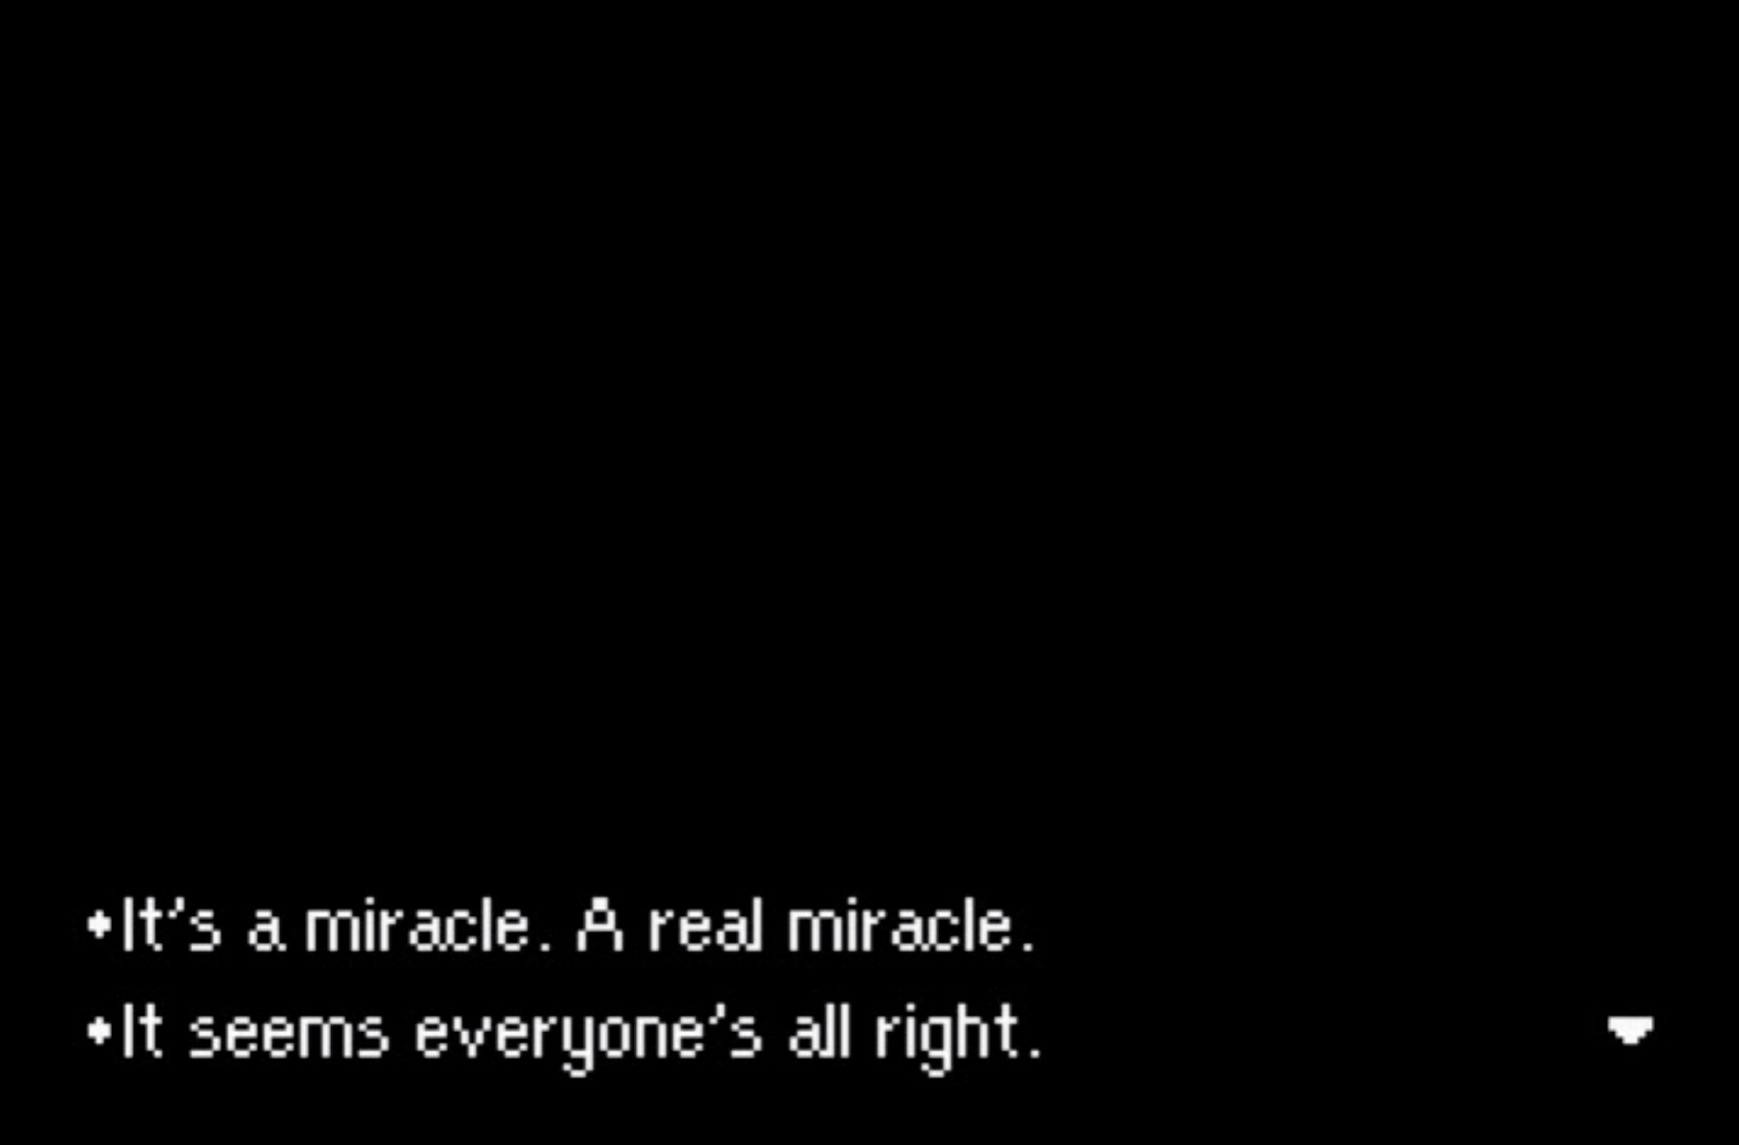

<https://www.youtube.com/watch?v=YTEwL0SRWxc>

